**STATURE SHARING**

**1. SRM Template**

- Functions on page SRM Template

*Figure 1-1. Action icons in page SRM Template*

- Some highlights:

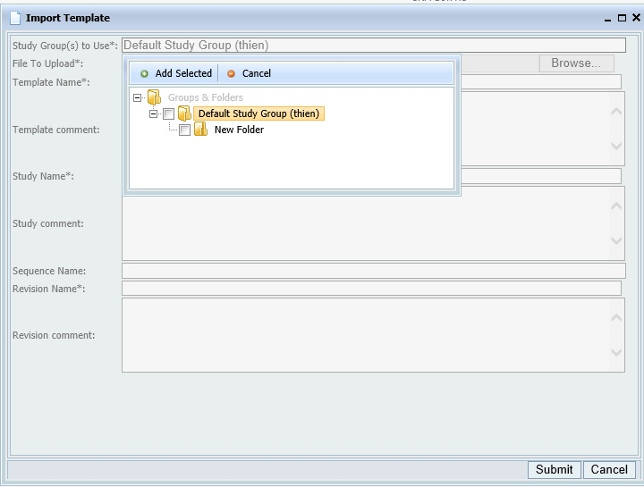+ Import template:

*Figure 1-2. Import template into specific folder*

+ …

+ Change View Groups

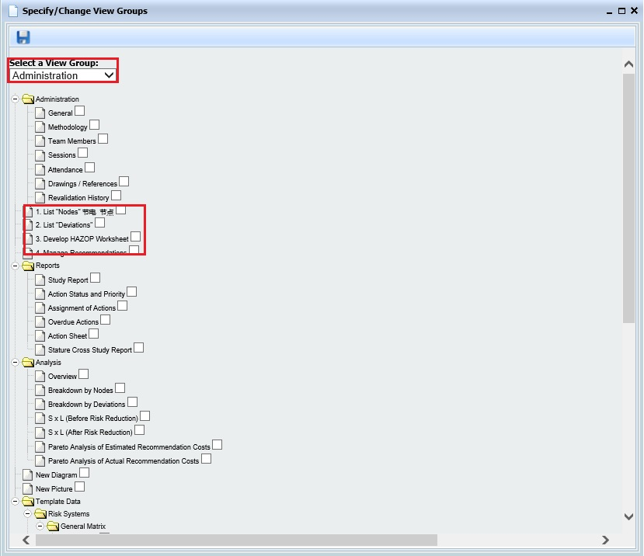*Figure 1-3. Change View Groups*

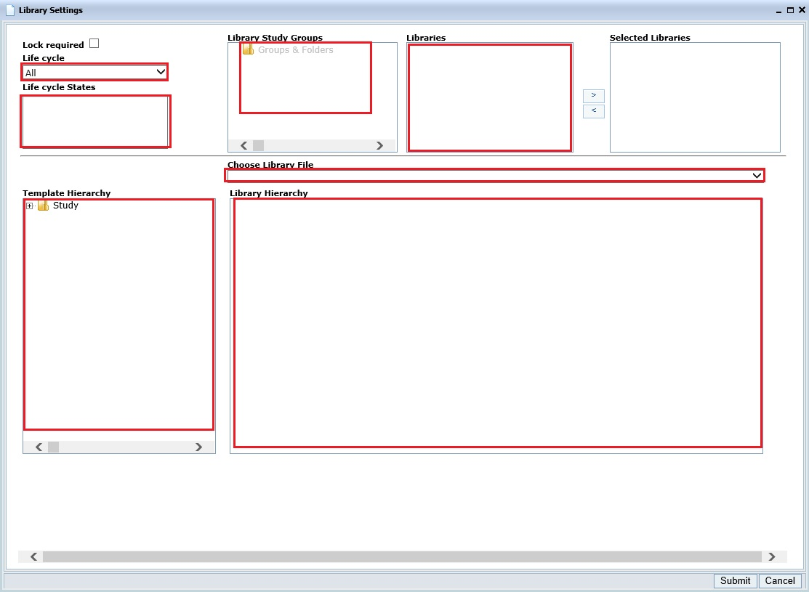+ Library Settings

*Figure 1-4. Library Settings*

**2. Users & Roles**

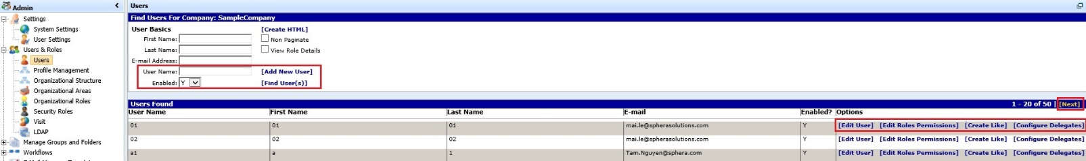- Admin table:

*Figure 2-1. Page Users*

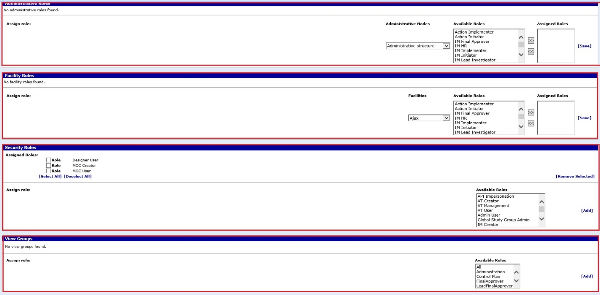

*Figure 2-2. Permissions session in page Users*

- Functions:

***+ getUser(docPermissions)***: Return a Bson Document as user data for testing at runtime (bonus: Remove user data which was selected from database).

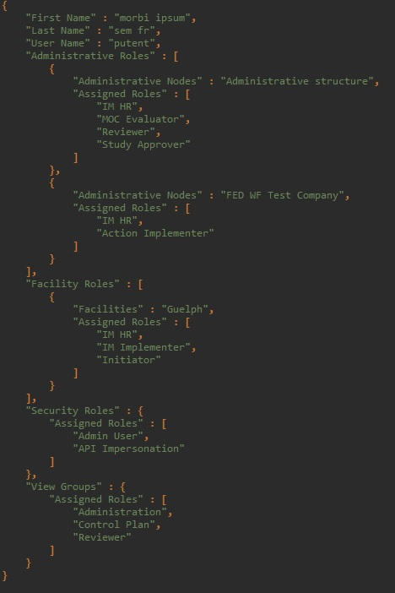

*Figure 2-3. Structure of input document “Permissions” from database*

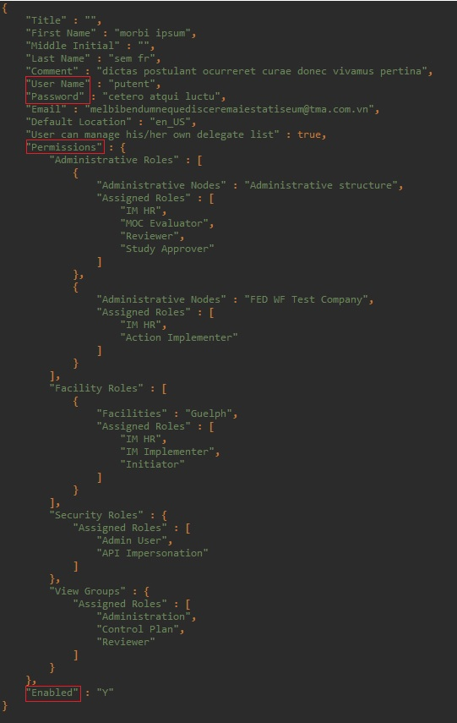

*Figure 2-4. Structure of return user data under Json Object view in database*

***+ updateUser(docUser)***: To update document “docUser” to database (“docUser” can get from ***getUser(docPermissions)*** function) => Should perform it at the end of test method after test ran.

***+ selectUser(docUser, strOption)***: To select a user with specific option in page Users & Roles. User will be created if not found in table result or edited if user config is not the same. If input “strOption” is **null** => prepare user for do nothing.

**3. DocumentHelper**

- To verify between Bson Documents: Using ***Assertion.***

- To find a Bson Document that satisfy conditions: Using ***Comparison***.

- 3 comparators: EQUALS, CONTAINS, MATCHES.

+ EQUALS: 2 documents are the same.

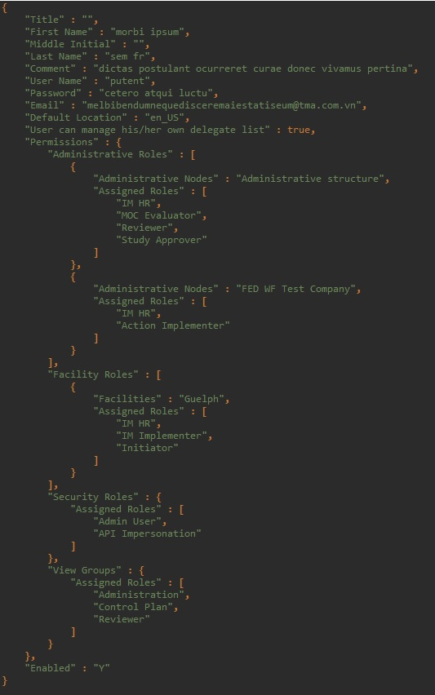+ CONTAINS:

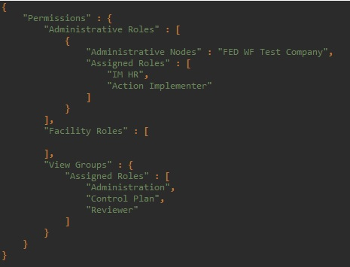

*Figure 3-2. Document B under Json Object view*

*Figure 3-1. Document A under Json Object view*

***i)*** Pairs of Key-Values that have in B are also have in A

=> A **contains** B

+ MATCHES:



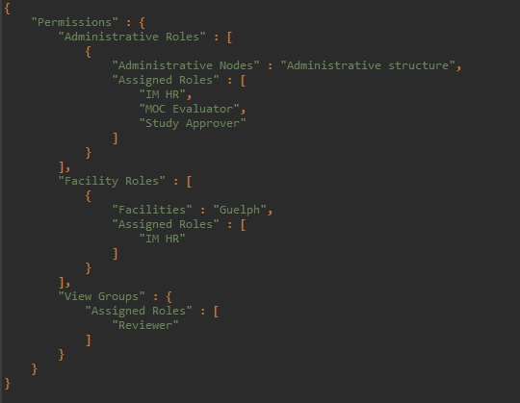

*Figure 3-4. Document D under Json Object view*

*Figure 3-3. Document C under Json Object view*

***i)*** Pairs of Key-Values that have in D are also have in C

***ii)*** List Values of C contains list Values of D with the same **Key** and **hierarchy level** in both documents.

=> C **matches** D

**4. Manage Groups and Folders**

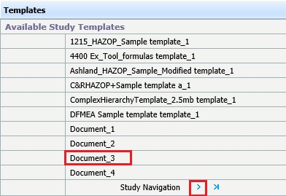

*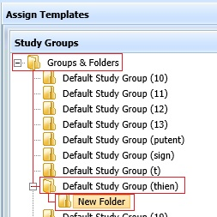 Figure 4-1. Hierarchy tree of folders Figure 4-2. Template to assign*

- Functions:

***+ makeLibrary(liFolders)***: To make a folder became Library (last element of list “liFolders”).

***+ assignTemplate(strTemplateName, liFolders)***: To assign 1 template with name “strTemplateName” into target folder (last element of list “liFolders”).

***+ assignTemplates(liTemplates, liFolders)***: To assign all templates in list “liTemplates” into target folder (last element of list “liFolders”).

**5. Another Changes**